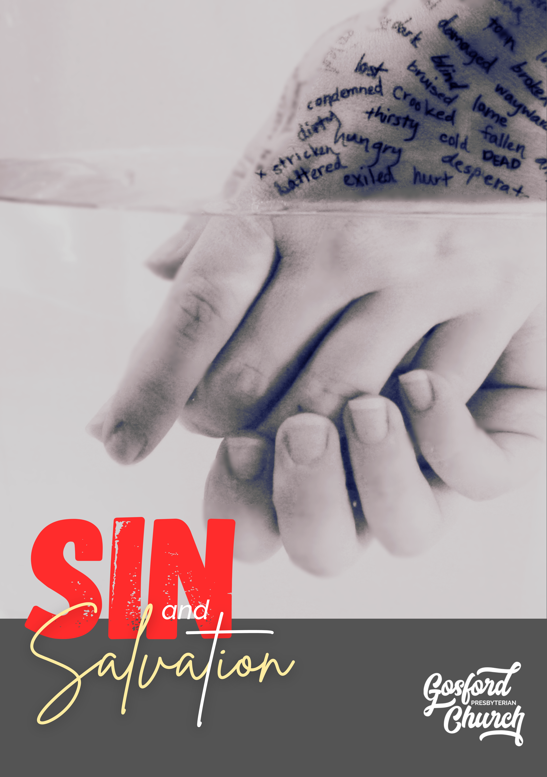

Study 1 : Monster

Read Genesis 3:1-7 and 6:1-5 (1 Timothy 3:5-7, 1 John 3:8, Jude 6, Rev 12:9)

1. Did sin exist prior to Adam and Eve’s disobedience? How?

2. What are the key characteristics of sin prior to Adam and Eve’s disobedience?

3. Are Adam and Eve and their descendants victims or perpetrators of sin? (Rom 5:12)

Read Genesis 4:6-7 and Romans 3:23-26 and 6:5-7
4. How is sin described in Genesis 4?

5. What is Cain to do with sin? What happens if he doesn’t?

6. How are we like Cain?

7. How do we get out from under the rule of sin?

Read Col 2:8, 2:13-15 and Romans 8:31-39
8. How do we live in Christ’s victory over sin?

Prayer
Pray for our link missionaries Rick and Tracey Rempel, serving with Mission Aviation Fellowship (MAF).

Study 2: Chaos

Read Genesis 1 and 2
1. How does God see order being maintained in his creation?

Read Genesis 3:1-8
2. What happens to the order of God’s creation? At whose hand?

3. What might this tell you about the nature of sin?

Read Genesis 4:6-7
4. What does it mean for God’s creation if Cain fails to rule over sin?

Read Psalm 8 and Hebrews 2:5-9, 14-16
5. How does God see order restored to his creation?

Read 2 Corinthians 5:17 and Ephesians 2:10
6. What is the goal of being in Christ?

Read Psalm 74:12-14, Isaiah 27:1 and Revelation 21:1
7. What is the significance of there being no sea in the new heavens and new earth?

8. What does it mean to be a part of the new creation while still in this old one?

When doing church? (1 Corinthians 14:26 and 33 and 40)

When doing life? (Heb 3:12-13)

Personally (Eph 4:20-5:4, Col 3:5-17)

Prayer
Pray for our link missionaries Rick and Kayleen Manton serving at Mount Druitt Indigenous Church, and the wider Indigenous Christian Community.

Study 3: Born This Way - Contagion

Read Genesis 1:27-31, Romans 2:14-15, Romans 3:23 1 Corinthians 15:21-22, 49 and Ecclesiastes 7:29
1. What does it mean to be made in the image of God?

2. How do you explain people’s tendency to seek out many ‘crooked’ schemes?

Read Romans 5:12-19, Psalm 51:5 and Ephesians 2:3
3. Why did we become sinners?

4. What is the consequence of being sinners?

5. How do we escape the consequence of being sinners?

Bonus question (for the keen beans)
6. Can you think of a situation where people can be simultaneously victims and perpetrators of evil?

Read 1 Kings 8:46, Romans 3:10-12 and 1 John 1:8
7. If sin were a disease, how far has it spread?

Genesis 6:6 and 8:21 and Jeremiah 17:9
8. How much of us does sin affect? And in what way?

Read Ephesians 4:20-24
9. What does it mean to live in Christ and not in Adam?

Prayer
Pray for our link missionary organisation Langham Partnership. Go to https://au.langham.org/global-resources/news-and-updates/ for updated news and prayer points.

Study 4: Misdirected Love

Read Genesis 6:5 and Jeremiah 17:9
1. What is the human heart like?

2. The word ‘deceitful’ in Jeremiah 17:9 is literally ‘crooked’. Some have extrapolated from this that the heart is bent in on itself. What do you put this down to? How does this help us think about sin?

Read Deuteronomy 6:4-5 and Exodus 20:3-5
3. What might we love more than God? (2 Tim 3:2, 1 John 2:15-16, Col 3:5, Phil 3:19)

For the keen beans: see The Westminster Confession of Faith Larger Catechism Question 105 and Answer for the many ways we might fail to love God. https://www.apuritansmind.com/westminster-standards/larger-catechism/

Read Romans 5:6-10
4. What does sin make us? (vs6, 8, 10)

Read Romans 5:1-2 and 6-10 again
5. What does faith in Jesus make us?

Read Romans 7:21-8:15 and Luke 7:36-50
6. How does Jesus turn our hearts and love towards God?

Prayer
Pray for Rob and El Falls serving at the Talua Theological Training Institute in Vanuatu, equipping the next generation of pastors, evangelists, and Church workers. Go to https://www.fallsvanuatu.info/ for updated news.

Study 5: Guilt

Read Leviticus 4:13-31 and Leviticus 17:11
1. According to Leviticus, what is sin?

2. How would you describe guilt?

3. How is guilt satisfied?

Read Matthew 6:9-13
4. How does Jesus describe sin? How can God forgive such a thing?

Read Leviticus 16 and Isaiah 52:13-53:12
5. What is the proper consequence of guilt?

6. How does God propose to acquit the guilty and satisfy the debt of their guilt?

Read Psalm 75:8, Matthew 26:39 and John 11:47-53
7. How does Jesus feature in God’s plan to deal with people’s guilt?

Read 1 Corinthians 15:3-4.
8. Paul says ‘Christ died for our sins according to the Scriptures’. Which Scriptures do you think Paul is referring to? What exactly does it mean that Christ died for our sins?

Read Romans 3:25-26 (see Lev 17:11)
9. What does the shedding of Christ’s blood accomplish for us? For God?

10. How does the shedding of Christ’s blood do this?

Read Romans 8:1-17
11. Who’s flesh did God condemn sin in? (vs 3)

12. How is it that Jesus' righteousness comes to us and our unrighteousness to him?

13. How do we live guilt free lives?

Prayer
Pray for our link missionaries Igal and Milana Vender with International Mission to Jewish People (IMJP) working in Tel Aviv, Israel. See www.imjp.org for more on IMPJ or imjp.org/homeless for more on Igal’s work.

Study 6: Pride

Read 1 Timothy 3:6, Genesis 3:5-6 and 1 John 2:15
1. How is sin described in these passages? Is there a common thread?

Read Genesis 11:1-9
2. What does this passage tell us about pride?

Read Proverbs 8:13 and James 4:6
3. What does God think about pride?

Read 1 Timothy 6:4-5
4. What kind of things does pride lead to?

5. What is pride the opposite of?

Read 1 Corinthians 13:4-7
6. How else would you describe pride?

7. What else is pride the opposite of?

Think about it
8. Can you identify any pride in your life?

Read Proverbs 16:18
9. What is the result of pride?

Read 2 Chronicles 32:24-26 and 1 Peter 5:5-6
10. What is the antidote to pride?

Read Philippians 2:3-11
What is the pattern in Jesus we can expect from God as we look to counter pride?

Prayer
Pray for our link missionaries James and Christine Thomas serving with Global Recordings Network. See https://globalrecordings.net/en/au for more on Global Recordings Network.
Study 7: Unbelief
Intro:
- Sinclair Ferguson said, ever since our ancestors plucked that first fruit – gave seed to that first unbelief, we have been plagued with the same lie. The lie is this, ‘If I truly trusted God, surrendered all to God, then I would be miserable’. Do you agree/disagree?

- Where do you see this lie present in your own heart/life?

Read Genesis 3:1-8
- What stands out to you/strikes you from this passage?

- What is the lie that the serpent tells?

- Discuss the different comments that unbelief makes about the character of God.

- What is the result of their unbelief?

Read Luke 22:39-44
- What stands out to you/strikes you from this passage?

- What similarities and differences do you note between Adam and Eve?

- What do we learn about belief/trust here?

- What does that testify about the character of God?

2 Case Studies: Read Matt 8:5-13 & Matt 15:21-28
- What stands out to you/strikes you from the passage?

- What are the similarities and differences between the two stories?

- How desperate are we for Jesus or to trust Him more?

- What obstacles stop us from being more like the woman or the centurion?

- How might we grow more like the woman or the centurion?

Further Discussion:
- How would you council/pastorally support someone who is struggling with belief/doubt and maybe feels their doubt disqualifies them from God?

And/or
- What ought we to then do when we are struggling with doubt?

And/or
- How would you pastorally address someone who says, ‘I believe – just no one is perfect’ and is indifferent/apathetic to trusting God with their actions?

Prayer
Pray for our link missionary organisation the Bible Society. See https://www.biblesociety.org.au/blog/pray-with-us/ for updated prayer points.

Study 8: Indwelling Sin
Introduction:
- We experience the brokenness of the world, we experience the sin and selfishness of others, but more than any other we experience the sin and selfishness of our own hearts. What do you find hardest/the most difficult to experience and why?

Read Romans 7:21-25
- What stands out to you/strikes you from this passage?

- In what sense would you describe the Christian life as being at peace? In what sense would you describe it as a battle? Explain.

- Paul uses quite emotive language; how would you describe how Paul’s emotions in this passage?

- What is it that grieves Paul? What is it that brings him joy?

- Do you ever struggle to honestly come to terms with the sinfulness within your own heart? Why/Why not?

- What are ways that we might seek to shift blame or guilt from our own heart to other things?

- How would you respond to someone who said, ‘Paul needs to have a more positive view of himself’?

Read Galatians 5:16-26
- What stands out to you/strikes you from this passage?

- What stands out to you from the Fruit of the Spirit?

- What stands out to you about the acts of the flesh?

- How does Paul say we are to treat our fleshly desires and passions? Does that mean we would be miserable/joyless people?

- Imagine our Church was to look like vs22-26. What things would change? What might that look like?

- How do you think we/I might grow in the Fruit of the Spirit?

Prayer
Pray for our link missionaries Matt and Mel Crocker as they serve at Grace Presbyterian Church in Wallsend.

Knowing Jesus, Loving People, Changing Lives

